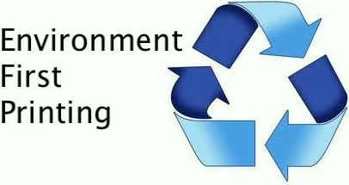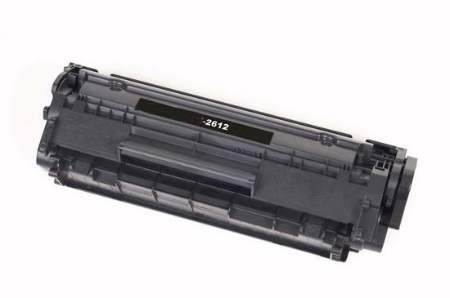

Product Warranty

Manufacturing Process
EFP’s cartridges will print as many copies and operate as well as or better than the brand name versions. EFP asserts the product is truly compatible to the brand name versions. Parts are replaced in the recycling process and we remanufacture it only once after it has been used by the original manufacturer.

Defective Cartridges
EFP will immediately replace any cartridge reported as defective, to insure the end-user may continue printing. EFP will take responsibility for retrieving the defective cartridge and any costs to do so.

Printer Repair
EFP will cover all parts and labor costs associated with a printer repair required as a result of a defective cartridge. EFP customers may secure the services of the repair technicians or require EFP to make such arrangements. Repair invoices should always be forwarded to EFP for payment. EFP requests customers to alert EFP to any repair needs immediately.

Printer Replacement
Should a cartridge damage a printer beyond repair EFP will replace the printer.

Matthew Airey
Vice President, Marketing
01/04/2013

Distributed by: Environment First Printing, LLC PO Box 4241 * Portsmouth, NH 03801
Ph 617-599-0526 * Fax 603-556-8845 * www.environmentfirstprinting.com

